Proposal
UHCL Communicator

Ridhima Joshi(1554546)
Nagarajan Sivagnanam Easwaramoorthi(1554916)
Mounika Vootukuru(1637566)
Lakshmi Sudheera Dama(1640838)

University Of Houston Clear Lake

Date : 10/03/17

Table of Content
- Introduction………………………………………………………….. 2
- Statement of the problem……………………………………………. 2
- Research Questions…………………………………………………...2
- Intent of the study…………………………………………………….2
- Methodology………………………………………………………….3
- Timeline……………………………………………………………....4
- References………………………………………………………….... 4

List of Tables
1.Tentative Timeline..............……………………………………4

List of Figures
1.Waterfall model ………………………………………………………………………………….3

Introduction
The current generation is all about mobile computing technologies and there is leaps of improvement shown by all the mobile applications recently developed. This innovation in mobile apps has raised interest in developing apps for students. The main goal of the app is to provide accurate information about the college and its activities so that the students joining the university would have the exact information they need from the college. The app is designed by using appropriate software model based on its requirements. Considering the difficulties faced by the freshmen joining the colleges this software model is being proposed.

Statement of the Problem

When new students join a university in a place different from their home land they may face various difficulties such as accommodation, food, clothing, and student associations related issues. Sometimes they might also want to know about the majors in the college and output of each course from other students studying in the university.

Research Questions
1. What are the complications that arise while building the application?
2. Which software process best suits for the development this application?

Intent of the study
Developing a mobile application by using traditional waterfall model.

Methodology
The UCHL Communicator will be needing the information of the new students as well as current students, which will be readily available in the university database. Hence all the possible requirements are known. The methodology adopted for the project will be the Waterfall model. The project development will be in a sequential pattern. The output of the first phase will be the input to the next phase. Hence waterfall model will be adopted for the development of the project.

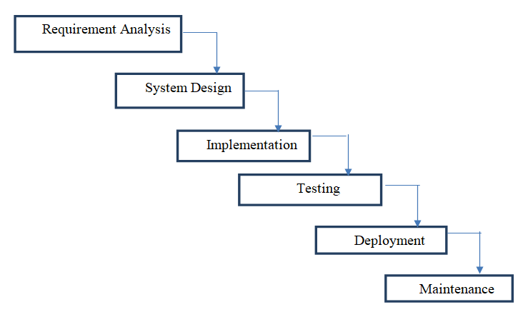

Figure 1: Waterfall model

Timeline

A tentative schedule for the research is given below
Milestone | Start Date | End date
Problem Statement/Purpose | 27-Sep-17 | 03-Oct-17
Research/Requirements | 04-Oct-17 | 24-Oct-17
Analysis and Design | 25-Oct-17 | 07-Nov-17
Coding | 08-Nov-17 | 28-Nov-17
Testing | 29-Nov-17 | 05-Dec-17
Deployment/Implementation | 06-Dec-17 | 09-Dec-17
Maintenance/Support | 10-Dec-17 | 13-Dec-17

Table 1: Tentative Timeline

References
- https://www.tutorialspoint.com/sdlc/sdlc_waterfall_model.htm
- https://www.nytimes.com/2014/08/28/nyregion/students-inventing-programs-to-streamline-their-colleges-data.html

